Skip/Pass time
Make it so you can fast forward in game time and regain health while doing so.
Many games allow players to rest or wait to move time forward. The "Skip Time" system lets the player do this by interacting with a chair, making it a helpful but optional feature. It works alongside the Time System, Day/Night System, and HP system, so those must already be set up.

When the player chooses to pass time, a sitting animation plays and the screen fades out. Time advances and the player’s HP is restored up to the maximum limit. The screen then fades back in, a message appears saying the player feels rested, and control returns to the player.

Follow the flowchart below:
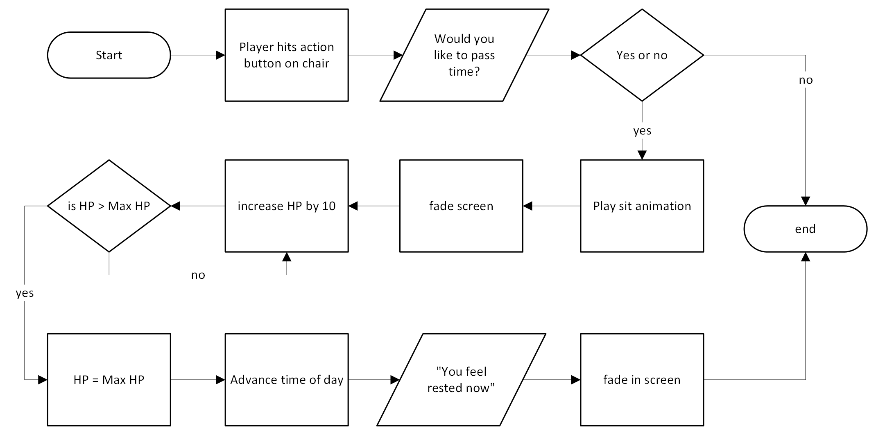

This should be used when you already have a day and night cycle in place. The “advance time of day” should be used to go from morning to afternoon, afternoon to evening, evening to night, night to midnight. You can add tint to the screen, so the player knows what time it is when they wake up and maybe an animation of you checking your watch for the time. This could be another item you could add that will give you that ability to check the time on the go.

